**GIT ASSIGNMENT**

**SECTION 0**

1. Create a directory ‘project_dir’ & cd to ‘project_dir’
2. Initialize git version database.
3. Create a new file index.html
4. Check the git status.You should find the index.html as untracked file.
5. Stage index.html file.
6. Commit index.html

Ans) I have done all the above tasks using the below commands.

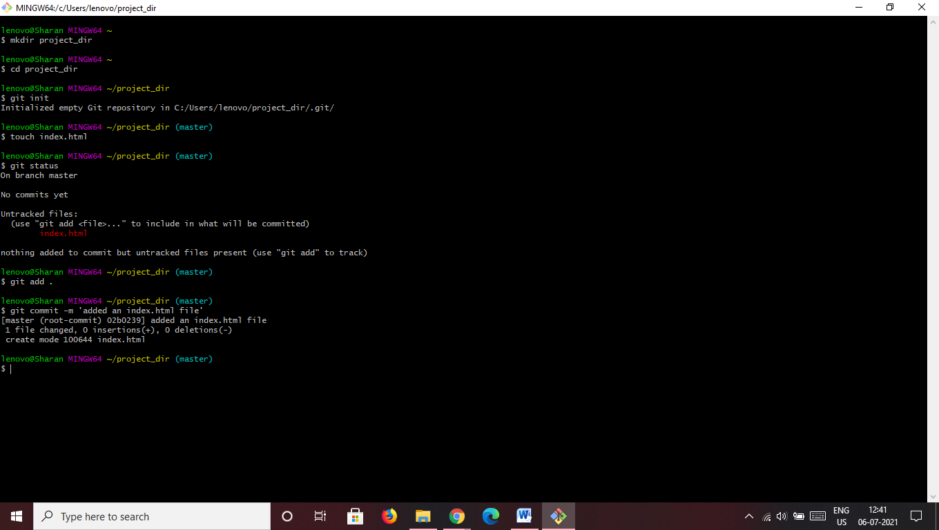

1. Make few changes to index.html and create new info.txt file
2. Check git status. Both the files need to be untracked.
3. Configure GIT to ignore .txt files
4. Again check git status and only .html file should be untracked.
5. State and commit index.html
6. Log all the comments so far.

Ans)

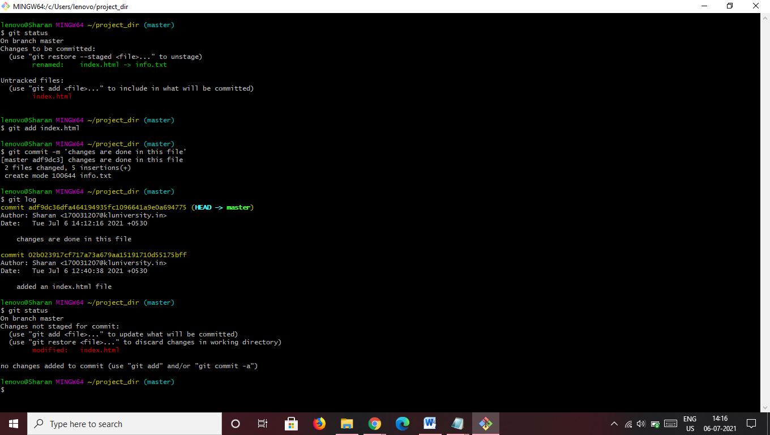

1. Make changes to index.hmtl
2. Revert the changes done in previous step.
3. Again change index.html
4. Stage index.html
5. Revert bavk the last stage.
6. Rename ‘add’ command to ‘my-add’
7. Using ‘my-add’ stage the index.hml file and commit changes

Ans)

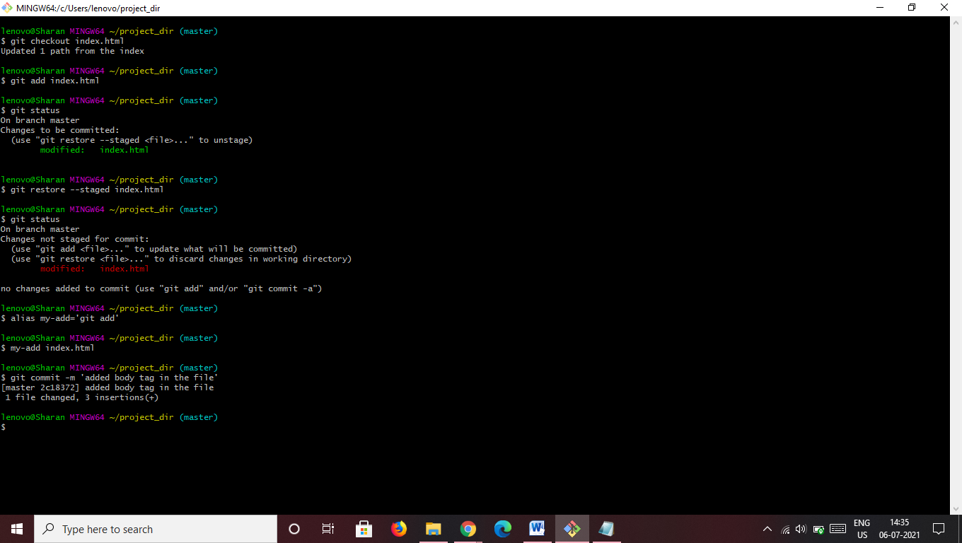

1. Revert last commit

Ans)

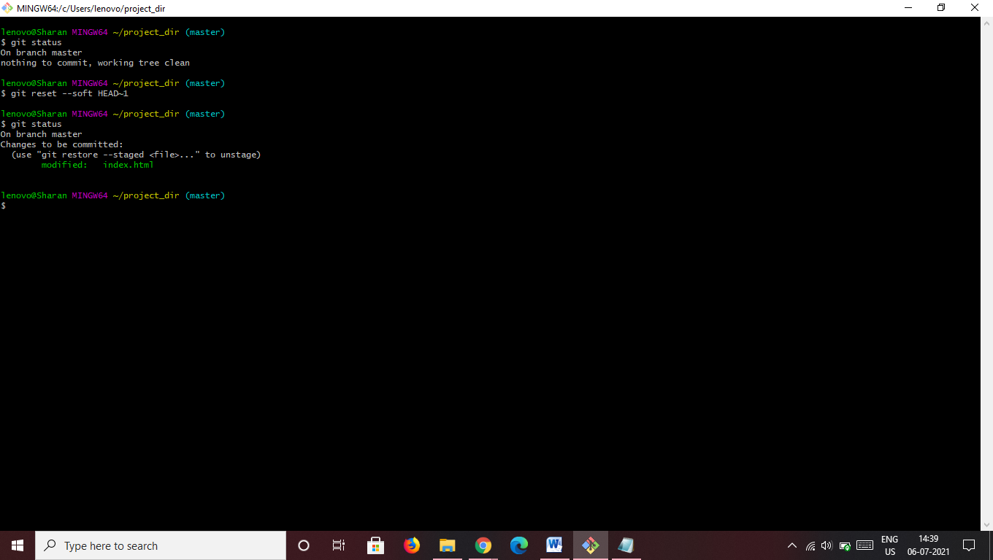

**GIT Branching**

**SECTION 1**

1. For taking a back-up of our assignments.
2. Create a new directory ‘Assignments’ & cd to ‘Assignments’
3. Create a README.txt file and write few lines in it.
4. Commit README.txt
5. Now create new branch ‘html-assignments’
6. Switch to ‘html-assignments’
7. Make some html files.
8. Commit the files into ‘html-assignments’

lenovo@Sharan MINGW64 ~

$ mkdir Assignments

lenovo@Sharan MINGW64 ~

$ cd Assignments

lenovo@Sharan MINGW64 ~/Assignments

$ git init

Initialized empty Git repository in C:/Users/lenovo/Assignments/.git/

lenovo@Sharan MINGW64 ~/Assignments (master)

$ touch README.txt

lenovo@Sharan MINGW64 ~/Assignments (master)

$ git add .

lenovo@Sharan MINGW64 ~/Assignments (master)

$ git commit -m 'a few lines are added in the file'

[master (root-commit) b466301] a few lines are added in the file

1 file changed, 1 insertion(+)

create mode 100644 README.txt

lenovo@Sharan MINGW64 ~/Assignments (master)

$ git branch html-assignments

lenovo@Sharan MINGW64 ~/Assignments (master)

$ git checkout html-assignments

Switched to branch 'html-assignments'

lenovo@Sharan MINGW64 ~/Assignments (html-assignments)

$ touch new.html

lenovo@Sharan MINGW64 ~/Assignments (html-assignments)

$ git add new.html

lenovo@Sharan MINGW64 ~/Assignments (html-assignments)

$ git commit -m 'created a html file'

[html-assignments 8c1b1c6] created a html file

1 file changed, 0 insertions(+), 0 deletions(-)

create mode 100644 new.html

**29-38**

lenovo@Sharan MINGW64 ~/Assignments (html-assignments)

$ git checkout master

Switched to branch 'master'

lenovo@Sharan MINGW64 ~/Assignments (master)

$ git add .

lenovo@Sharan MINGW64 ~/Assignments (master)

$ git commit -m 'updated the text file'

[master 90f7ecf] updated the text file

1 file changed, 2 insertions(+), 1 deletion(-)

lenovo@Sharan MINGW64 ~/Assignments (master)

$ git checkout html-assignments

Switched to branch 'html-assignments'

lenovo@Sharan MINGW64 ~/Assignments (html-assignments)

$ git add .

lenovo@Sharan MINGW64 ~/Assignments (html-assignments)

$ git commit -m 'updated the html file'

[html-assignments 6ac6f5c] updated the html file

1 file changed, 3 insertions(+)

lenovo@Sharan MINGW64 ~/Assignments (html-assignments)

$ git checkout master

Switched to branch 'master'

lenovo@Sharan MINGW64 ~/Assignments (master)

$ git merge html-assignments

Merge made by the 'recursive' strategy.

new.html | 8 ++++++++

1 file changed, 8 insertions(+)

create mode 100644 new.html

lenovo@Sharan MINGW64 ~/Assignments (master)

$ git branch -d html-assignments

Deleted branch html-assignments (was 6ac6f5c).

**SECTION 2**

**1-14**

lenovo@Sharan MINGW64 ~/Assignments (master)

$ git branch css-assignments

lenovo@Sharan MINGW64 ~/Assignments (master)

$ git checkout css-assignments

Switched to branch 'css-assignments'

lenovo@Sharan MINGW64 ~/Assignments (css-assignments)

$ touch css.txt

lenovo@Sharan MINGW64 ~/Assignments (css-assignments)

$ git add .

lenovo@Sharan MINGW64 ~/Assignments (css-assignments)

$ git commit -m 'created a css text file'

[css-assignments e234aef] created a css text file

1 file changed, 0 insertions(+), 0 deletions(-)

create mode 100644 css.txt

lenovo@Sharan MINGW64 ~/Assignments (css-assignments)

$ git add .

lenovo@Sharan MINGW64 ~/Assignments (css-assignments)

$ git commit -m 'added new line in README.txt'

[css-assignments 8498968] added new line in README.txt

1 file changed, 1 insertion(+)

lenovo@Sharan MINGW64 ~/Assignments (css-assignments)

$ git checkout master

Switched to branch 'master'

lenovo@Sharan MINGW64 ~/Assignments (master)

$ git add .

lenovo@Sharan MINGW64 ~/Assignments (master)

$ git commit -m 'added new line from mastser in README.txt'

[master 0bad0f1] added new line from mastser in README.txt

1 file changed, 1 insertion(+)

lenovo@Sharan MINGW64 ~/Assignments (master)

$ git checkout css-assignments

Switched to branch 'css-assignments'

lenovo@Sharan MINGW64 ~/Assignments (css-assignments)

$ git add .

lenovo@Sharan MINGW64 ~/Assignments (css-assignments)

$ git commit -m 'changed the css file'

[css-assignments 39aa841] changed the css file

1 file changed, 1 insertion(+)

lenovo@Sharan MINGW64 ~/Assignments (css-assignments)

$ git checkout master

Switched to branch 'master'

lenovo@Sharan MINGW64 ~/Assignments (master)

$ git merge css-assignments

Auto-merging README.txt

Merge made by the 'recursive' strategy.

README.txt | 1 +

css.txt | 1 +

2 files changed, 2 insertions(+)

create mode 100644 css.txt

lenovo@Sharan MINGW64 ~/Assignments (master)

$ git branch -d css-assignments

Deleted branch css-assignments (was 39aa841).

**SECTION 3**

**1-14**

lenovo@Sharan MINGW64 ~/Assignments (master)

$ git branch js-assignments

lenovo@Sharan MINGW64 ~/Assignments (master)

$ git checkout js-assignments

Switched to branch 'js-assignments'

lenovo@Sharan MINGW64 ~/Assignments (js-assignments)

$ touch js.txt

lenovo@Sharan MINGW64 ~/Assignments (js-assignments)

$ git add .

lenovo@Sharan MINGW64 ~/Assignments (js-assignments)

$ git commit -m 'added a js file'

[js-assignments a3c5442] added a js file

1 file changed, 0 insertions(+), 0 deletions(-)

create mode 100644 js.txt

lenovo@Sharan MINGW64 ~/Assignments (js-assignments)

$ git add .

lenovo@Sharan MINGW64 ~/Assignments (js-assignments)

$ git commit -m 'updated the README.txt file'

[js-assignments 6638bc8] updated the README.txt file

1 file changed, 1 insertion(+), 1 deletion(-)

lenovo@Sharan MINGW64 ~/Assignments (js-assignments)

$ git checkout master

Switched to branch 'master'

lenovo@Sharan MINGW64 ~/Assignments (master)

$ git add .

lenovo@Sharan MINGW64 ~/Assignments (master)

$ git commit -m 'updated the README.txt file from master'

[master 8fcd99a] updated the README.txt file from master

1 file changed, 1 insertion(+), 1 deletion(-)

lenovo@Sharan MINGW64 ~/Assignments (master)

$ git checkout js-assignments

Switched to branch 'js-assignments'

lenovo@Sharan MINGW64 ~/Assignments (js-assignments)

$ git add .

lenovo@Sharan MINGW64 ~/Assignments (js-assignments)

$ git commit -m 'changed js file'

[js-assignments f0792a8] changed js file

1 file changed, 1 insertion(+)

lenovo@Sharan MINGW64 ~/Assignments (js-assignments)

$ git checkout master

Switched to branch 'master'

lenovo@Sharan MINGW64 ~/Assignments (master)

$ git merge js-assignments

Auto-merging README.txt

CONFLICT (content): Merge conflict in README.txt

Automatic merge failed; fix conflicts and then commit the result.

lenovo@Sharan MINGW64 ~/Assignments (master|MERGING)

$ git add .

lenovo@Sharan MINGW64 ~/Assignments (master|MERGING)

$ git commit -m 'modified the file'

[master f81608b] modified the file

lenovo@Sharan MINGW64 ~/Assignments (master)

$ git merge js-assignments

Already up to date.

lenovo@Sharan MINGW64 ~/Assignments (master)

$ git branch -d js-assignments

Deleted branch js-assignments (was f0792a8).

**GIT Remoting**

**SECTION 3**

**39-42**

lenovo@Sharan MINGW64 ~

$ git config --global user.sharu918

lenovo@Sharan MINGW64 ~

$ cd Assignments

lenovo@Sharan MINGW64 ~/Assignments (master)

$ git remote add origin https://github.com/sharu918/freshersbatch-jun21.git

lenovo@Sharan MINGW64 ~/Assignments (master)

$ git push origin master

Select an authentication method for 'https://github.com/':

1. Web browser (default)

2. Personal access token

option (enter for default): 1

info: please complete authentication in your browser...

Enumerating objects: 45, done.

Counting objects: 100% (45/45), done.

Delta compression using up to 4 threads

Compressing objects: 100% (39/39), done.

Writing objects: 100% (45/45), 4.61 KiB | 112.00 KiB/s, done.

Total 45 (delta 8), reused 0 (delta 0), pack-reused 0

remote: Resolving deltas: 100% (8/8), done.

To https://github.com/sharu918/freshersbatch-jun21.git

* [new branch] master -> master

**SECTION 4**

